

**Web Programming**

Lab task



Name : M. Ahmed

Roll No: 21F-9295

Section : 6-E

Task : 1

<!DOCTYPE html>

<html lang="en">

<head>

    <meta charset="UTF-8">

    <meta name="viewport" content="width=device-width, initial-scale=1.0">

    <title>CSS</title>

    <link rel="stylesheet" href="Style.css">

</head>

<style>

    .container{

    background-color: #2f3640;

    height: 200px;

    color: white;

    padding-top: 20px;

    padding-left: 20px;

}

.title{

    font-size: 40px;

    font-family: Arial, Helvetica, sans-serif;

}

.subtitle{

    margin-top: 15px;

}

.start-btn{

    margin-top: 20px;

    background-color: #2ecc71;

    height: 50px;

    border-radius: 7px;

    color: white;

}

</style>

<body>

    <div class="container">

        <div class="title">Start CSS Exercise</div>

        <div class="subtitle">Good luck!</div>

        <button class="start-btn">Start CSS Exercises ></button>

    </div>

</body>

</html>

Task : 2

<!DOCTYPE html>

<html lang="en">

<head>

    <meta charset="UTF-8">

    <meta name="viewport" content="width=device-width, initial-scale=1.0">

    <title>React</title>

    <link rel="stylesheet" href="Style.css">

</head>

<style>

.registration-form{

    background-color: #2980b9;

    height: 400px;

    width: 600px;

    position: relative;

    left: 450px;

    top: 100px;

}

.input-name{

    width: 300px;

    margin-left: 140px;

    margin-top: 50px;

    height: 30px;

}

.input-username{

    width: 300px;

    margin-left: 140px;

    margin-top: 13px;

    height: 30px;

}

.input-password{

    width: 300px;

    margin-left: 140px;

    margin-top: 13px;

    height: 30px;

}

.input-number{

    width: 300px;

    margin-left: 140px;

    margin-top: 13px;

    height: 30px;

}

.input-email{

    width: 300px;

    margin-left: 140px;

    margin-top: 13px;

    height: 30px;

}

.submit-btn{

    width: 310px;

    margin-left: 140px;

    margin-top: 13px;

    height: 30px;

    background-color: red;

    color: white;

}

</style>

<body>

    <form class="registration-form">

        <input type="text" placeholder="Name*" class="input-name"><br>

        <input type="text" placeholder="Username*" class="input-username"><br>

        <input type="password" placeholder="Password*" class="input-password"><br>

        <input type="number" placeholder="Number*" class="input-number"><br>

        <input type="email" placeholder="Email id*" class="input-email"><br>

        <input type="submit" value="Register" class="submit-btn">

    </form>

</body>

</html>

Task : 3

<!DOCTYPE html>

<html lang="en">

<head>

    <meta charset="UTF-8">

    <meta name="viewport" content="width=device-width, initial-scale=1.0">

    <title>Document</title>

    <link rel="stylesheet" href="Style.css">

</head>

<style>

    .container{

    width: 310px;

    height: 350px;

    box-shadow: 2px 2px 20px 2px 2px ;

}

.image{

    object-fit: fill;

    width: 300px;

    height: 250px;

}

.caption{

    color:black;

    font-weight: bold;

    font-size: 20px;

    text-align: center;

    padding-top: 20px;

}

</style>

<body>

    <div class="container">

        <div class="image-container">

            <img src="image.jpeg" class="image">

        </div>

        <div class="caption">

            Cinque Terre

        </div>

    </div>

</body>

</html>

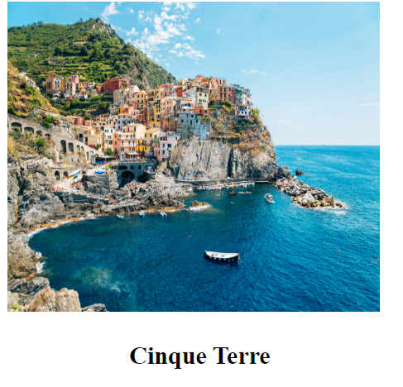

Task : 4

<!DOCTYPE html>

<html lang="en">

<head>

    <meta charset="UTF-8">

    <meta name="viewport" content="width=device-width, initial-scale=1.0">

    <title>Document</title>

    <link rel="stylesheet" href="Style.css">

</head>

<style>

    @keyframes slideIn {

    0% {

        transform: translateX(-100%);

        opacity: 0;

    }

    100% {

        transform: translateX(0);

        opacity: 1;

    }

}

.container{

    width: 310px;

    height: 350px;

    box-shadow: 2px 2px 20px 2px 2px;

    animation: slideIn 2s ease-in-out forwards;

}

.image{

    object-fit: fill;

    width: 300px;

    height: 250px;

}

.caption{

    color: black;

    font-weight: bold;

    font-size: 20px;

    text-align: center;

    padding-top: 20px;

    capacity: 0;

}

</style>

<body>

    <div class="container">

        <div class="image-container">

            <img src="image.jpeg" class="image">

        </div>

        <div class="caption">

            Cinque Terre

        </div>

    </div>

</body>

</html>

